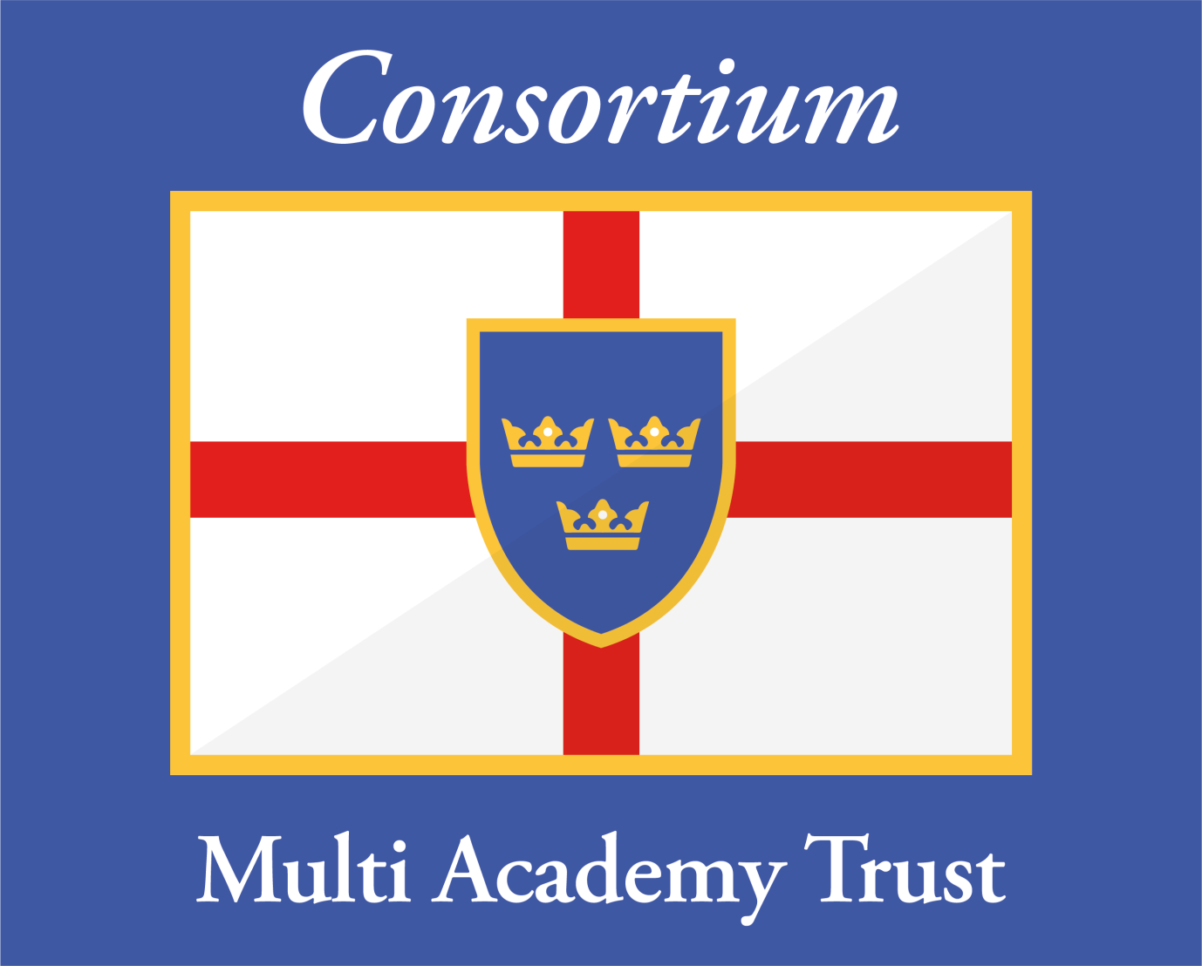
The Consortium Multi Academy Trust
CEO & Principal: Mr Andrew Aalders-Dunthorne
Email: principal@consortiumacademy.org
Chair of Board of Trustees & Members: Mrs Dawn Carman-Jones
Email: chair@consortiumacademy.org

Emergency Point of Contact (EPOC) &
Designated Safeguarding Lead (DSL)

Summer Half Term 2019

For site issues:

Mr Andrew Aalders-Dunthorne
07908 262623
principal@consortiumacademy.org

Designated Safeguarding Lead (DSL)
for safeguarding concerns and disclosures:

Mr Andrew Aalders-Dunthorne
07908 262623
principal@consortiumacademy.org

with effect from Saturday 25th May 2019 to Sunday 2nd June 2019

